Chapter 2

**Geometric entities**

* **Rasterization** is the process of selecting desired pixels to display on the raster screen (to present an Entity).

**Algorithm**

* Important steps of the graphics algorithm are the **declaration of variables**, **initialization**, **calculation**, and **plotting pixels**. Steps in an algorithm are shown in Fig. 2.1.

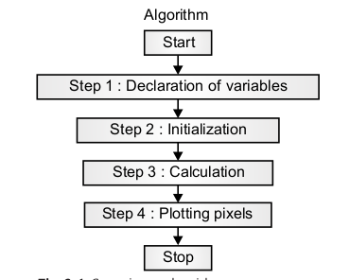

1. ***Declaration of variables***: All variables which are going to be used in the algorithm are declared in this step, along with the types of variables (integer, float, etc.).
2. ***Initialization***: Initialize the variables which the compiler will need to ask at the time of the program is executed.
3. ***Calculation***: What calculations are necessary to perform the algorithm?
4. ***Plotting pixels***: Apply the logic to plotting the points on the raster screen.

* **The three algorithms for line generation**:

1. *Equation of line algorithm*
2. *Digital differential analyzer (DDA) algorithm*
3. *Bresenham’s line generation algorithm.*

* Circles and ellipses will be generated by using Bresenham’s midpoint algorithm.
* Arcs will be generated by using trigonometric function.

**LINE GENERATION ALGORITHM USING**

**EQUATION OF LINE**

* A line is a very basic geometrical entity. Fig. 2.2 shows a line having end points A and B.

**Line Generation**

* Vector display are well suited for lines display.
* An appropriate controlled voltage is supplied to x and y deflection circuitry for vector display to generate a line.
* The nature of raster-graphics display, however, only allows us to display a
* discrete approximation of a line since the process is restricted to turning on
* only discrete points or pixels.
* c